These Great Community Partners
are promoting
Neighborhood Heroes:
Making A Difference
across the Chicago Region
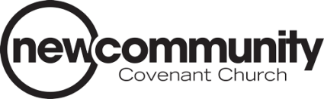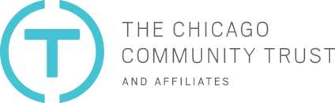
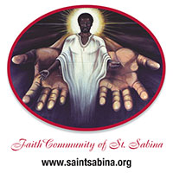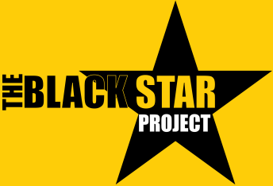

We are proud. We are committed. We can make a difference.
We all have the potential to make a difference where we live. That is what Neighborhood Heroes is all about. When we invest our time, get to know our neighbors and work together, we are creating stronger neighborhoods.
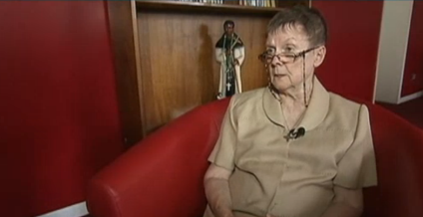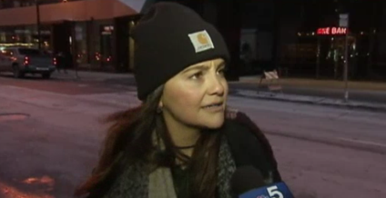
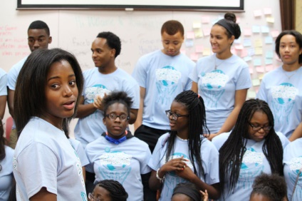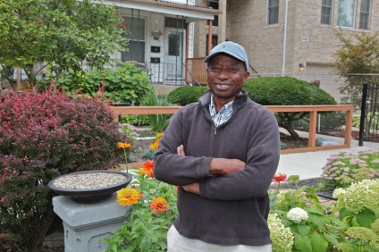
Some Neighborhood Heroes! Top left, Sister Therese O'Sullivan, Chicago's Woodlawn Neighborhood; top right, Hilary Verhaeghe, Chicago's Loop Neighborhood; bottom left, Destiny Watson, Flossmour, Illinois; and bottom right, William Hill, Chicago's Woodlawn Neighborhood.

Every act - no matter how big or small - can make a difference. When we care about each other and make a commitment to our block our community thrives. That is why NBC Chicago,
Telemundo Chicago, St. Sabina Church, The Black Star Project, New Community Covenant Church and The Chicago Community Trust have joined together to enlist Neighborhood Heroes from across the Chicago region and help tell their stories.

Click Here to "Take The Pledge" to Improve Our Neighborhoods and Become a Neighborhood Hero
Click Here to Read Stories of Neighborhood Heroes
Click Here to Learn About the Community Partners

